🎯 Project Overview
What you're building: A Spark-based system that analyzes hospital patient data to find where delays happen in the journey (Admission → Treatment → Discharge), instead of predicting disease.
Tools you'll use:
Tool | Purpose
VS Code | Main editor (code + notebook + terminal in one window)
Python venv | Isolated Python environment
PySpark | Distributed data processing + MLlib
Jupyter (inside VS Code) | Run code cell-by-cell, see outputs
Matplotlib / Seaborn | Charts
Git + GitHub | Version control + submission

📁 PHASE 0 — Final Folder Structure (Target)
This is what your project will look like at the end. Keep this in mind so your teacher sees a clean repo:
bottleneck-miner/
├── data/
│ └── healthcare_dataset.csv
├── notebooks/
│ └── bottleneck_miner.ipynb
├── output/
│ ├── hospital_bottleneck.csv
│ ├── condition_admission_bottleneck.csv
│ ├── bottleneck_drivers.csv
│ ├── hospital_clusters.csv
│ ├── flagged_cases.csv
│ ├── fig_hospital_los.png
│ └── fig_heatmap.png
├── .gitignore
├── README.md
└── requirements.txt

🔧 PHASE 1 — Project Setup (15 min)
Step 1.1 — Open PowerShell & Go to Your Project Folder
folder is D:\bottleneck-miner
first command :
powershell
cd D:\bottleneck-miner
step 2
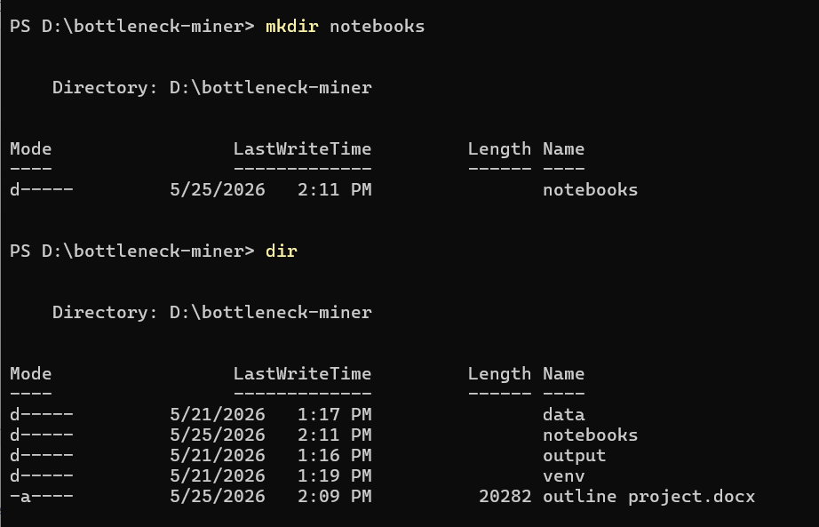
now
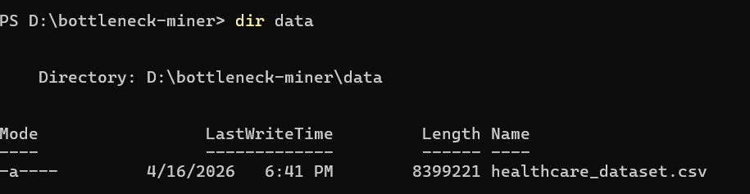

java installation verification check :
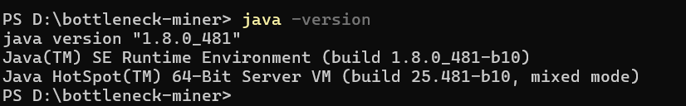

Step 1.5 — Create Python Virtual Environment
python -m venv venv
.\venv\Scripts\activate

Step 1.6 — Install Required Packages
pip install --default-timeout=300 pyspark==3.5.1 pandas matplotlib seaborn jupyter findspark pyarrow ipykernel
Wait 3–5 minutes (PySpark is big).
Step 1.7 — Save Dependencies to requirements.txt
powershell
pip freeze > requirements.txt

💻 PHASE 2 — Open Project in VS Code (5 min)
Step 2.1 — Launch VS Code in Your Folder
Step 2.2 — Install VS Code Extensions (one-time)
In VS Code's left sidebar, click Extensions icon (Ctrl+Shift+X) and install:
- Python (by Microsoft)
- Jupyter (by Microsoft)
Step 2.3 — Select the Python Interpreter
- Press Ctrl+Shift+P → type "Python: Select Interpreter" → choose the one inside .\venv\Scripts\python.exe.
Step 2.4 — Create the Notebook.
📊 PHASE 3 — Build the Notebook (2–3 hours)
Each block below = one notebook cell. Type code → press Shift+Enter to run.

- In VS Code file explorer, right-click the notebooks/ folder → New File → name it bottleneck_miner.ipynb.
- Open it. Top-right corner, click "Select Kernel" → pick the venv Python.
You're ready to code.
import findspark
findspark.init()

from pyspark.sql import SparkSession
from pyspark.sql import functions as F

spark = (SparkSession.builder
.appName("PatientJourneyBottleneckMiner")
.config("spark.sql.shuffle.partitions", "8")
.config("spark.driver.memory", "4g")
.getOrCreate())

spark.sparkContext.setLogLevel("WARN")
print("Spark version:", spark.version)
✅ Expected: Spark version: 3.5.1

Cell 2 — Load the CSV
⚠️ Since the notebook is in notebooks/, the dataset path becomes ../data/:
df = (spark.read
.option("header", True)
.option("inferSchema", True)
.csv("../data/healthcare_dataset.csv"))

print("Total rows:", df.count())
df.printSchema()
df.show(5, truncate=False)

Cell 3 — Clean Data + Build Length-of-Stay
# Snake_case column names
clean = df.toDF(*[c.lower().replace(" ", "_") for c in df.columns])

# Cast types
clean = (clean
.withColumn("date_of_admission", F.to_date("date_of_admission"))
.withColumn("discharge_date", F.to_date("discharge_date"))
.dropna(subset=["date_of_admission", "discharge_date", "hospital"])
.withColumn("billing_amount", F.col("billing_amount").cast("double"))
.withColumn("age", F.col("age").cast("int")))

# ⭐ Core metric
clean = clean.withColumn("length_of_stay",
F.datediff("discharge_date", "date_of_admission"))

clean = clean.filter((F.col("length_of_stay") >= 0) & (F.col("length_of_stay") <= 60))

clean = clean.withColumn("age_band",
F.when(F.col("age") < 18, "0-17")
.when(F.col("age") < 35, "18-34")
.when(F.col("age") < 55, "35-54")
.when(F.col("age") < 70, "55-69")
.otherwise("70+"))

clean = clean.withColumn("cost_per_day",
F.when(F.col("length_of_stay") > 0,
F.col("billing_amount") / F.col("length_of_stay"))
.otherwise(F.col("billing_amount")))

clean.cache()
print("Cleaned rows:", clean.count())
clean.select("hospital", "medical_condition", "admission_type",
"length_of_stay", "cost_per_day", "age_band").show(5)

Cell 4 — Hospital Bottleneck Ranking (Spark SQL)
clean.createOrReplaceTempView("journey")

hospital_bottleneck = spark.sql("""
SELECT hospital,
COUNT(*) AS admissions,
ROUND(AVG(length_of_stay), 2) AS avg_los_days,
ROUND(PERCENTILE_APPROX(length_of_stay, 0.5), 2) AS median_los,
ROUND(PERCENTILE_APPROX(length_of_stay, 0.9), 2) AS p90_los,
ROUND(AVG(billing_amount), 2) AS avg_bill,
ROUND(AVG(cost_per_day), 2) AS avg_cost_per_day
FROM journey
GROUP BY hospital
HAVING COUNT(*) >= 20
ORDER BY avg_los_days DESC
""")
hospital_bottleneck.show(15, truncate=False)
hospital_bottleneck.coalesce(1).write.mode("overwrite").csv("../output/hospital_bottleneck", header=True)

🔹 Cell 5 — Condition × Admission Type Analysis
cond_admit = spark.sql("""
SELECT medical_condition, admission_type,
COUNT(*) AS n,
ROUND(AVG(length_of_stay), 2) AS avg_los,
ROUND(PERCENTILE_APPROX(length_of_stay, 0.9), 2) AS p90_los
FROM journey
GROUP BY medical_condition, admission_type
ORDER BY avg_los DESC
""")
cond_admit.show(30)
cond_admit.coalesce(1).write.mode("overwrite").csv("../output/condition_admission_bottleneck", header=True)

🔹 Cell 6 — Flag Bottleneck Cases (Window Function)
from pyspark.sql.window import Window
w = Window.partitionBy("hospital")
flagged = (clean
.withColumn("hospital_p90", F.expr("percentile_approx(length_of_stay, 0.9)").over(w))
.withColumn("is_bottleneck", (F.col("length_of_stay") > F.col("hospital_p90")).cast("int")))

bottleneck_drivers = (flagged.filter(F.col("is_bottleneck") == 1)
.groupBy("hospital", "medical_condition", "admission_type")
.agg(F.count("*").alias("delayed_cases"),
F.round(F.avg("length_of_stay"), 2).alias("avg_los"))
.orderBy(F.desc("delayed_cases")))
bottleneck_drivers.show(20, truncate=False)
bottleneck_drivers.coalesce(1).write.mode("overwrite").csv("../output/bottleneck_drivers", header=True)
🔹 Cell 7 — MLlib: Predict Length of Stay (GBT Regressor)
from pyspark.ml.feature import StringIndexer, OneHotEncoder, VectorAssembler, StandardScaler
from pyspark.ml.regression import GBTRegressor
from pyspark.ml.clustering import KMeans
from pyspark.ml import Pipeline
from pyspark.ml.evaluation import RegressionEvaluator

cat_cols = ["gender", "medical_condition", "admission_type", "insurance_provider", "age_band"]
indexers = [StringIndexer(inputCol=c, outputCol=c+"_idx", handleInvalid="keep") for c in cat_cols]
encoders = [OneHotEncoder(inputCol=c+"_idx", outputCol=c+"_oh") for c in cat_cols]

assembler = VectorAssembler(
inputCols=[c+"_oh" for c in cat_cols] + ["age", "billing_amount"],
outputCol="features")

gbt = GBTRegressor(featuresCol="features", labelCol="length_of_stay", maxIter=50)
pipe = Pipeline(stages=indexers + encoders + [assembler, gbt])

train, test = clean.randomSplit([0.8, 0.2], seed=42)
model = pipe.fit(train)
pred = model.transform(test)

rmse = RegressionEvaluator(labelCol="length_of_stay", metricName="rmse").evaluate(pred)
r2 = RegressionEvaluator(labelCol="length_of_stay", metricName="r2").evaluate(pred)
print(f"LoS Prediction — RMSE: {rmse:.2f} days | R²: {r2:.3f}")
🔹 Cell 8 — MLlib: Cluster Hospitals (KMeans)
hosp_features = hospital_bottleneck.na.fill(0)
va = VectorAssembler(
inputCols=["avg_los_days", "p90_los", "avg_cost_per_day", "admissions"],
outputCol="raw")
scaler = StandardScaler(inputCol="raw", outputCol="features", withMean=True, withStd=True)
km = KMeans(k=3, seed=42, featuresCol="features", predictionCol="cluster")

cluster_model = Pipeline(stages=[va, scaler, km]).fit(hosp_features)
clustered = cluster_model.transform(hosp_features).select(
"hospital", "avg_los_days", "p90_los", "avg_cost_per_day", "admissions", "cluster")
clustered.orderBy("cluster", F.desc("avg_los_days")).show(50, truncate=False)
clustered.coalesce(1).write.mode("overwrite").csv("../output/hospital_clusters", header=True)
📝 Interpret clusters: highest avg_los = Bottleneck, lowest = Efficient, middle = Average.

Cell 9 — Charts
import matplotlib.pyplot as plt
import seaborn as sns

hb_pd = hospital_bottleneck.limit(15).toPandas()
ca_pd = cond_admit.toPandas()

# Chart 1
plt.figure(figsize=(10, 5))
sns.barplot(data=hb_pd, x="avg_los_days", y="hospital", palette="Reds_r")
plt.title("Top 15 Hospitals by Average Length of Stay")
plt.xlabel("Avg LoS (days)")
plt.tight_layout()
plt.savefig("../output/fig_hospital_los.png", dpi=120)
plt.show()

# Chart 2
pivot = ca_pd.pivot(index="medical_condition", columns="admission_type", values="avg_los")
plt.figure(figsize=(8, 6))
sns.heatmap(pivot, annot=True, fmt=".1f", cmap="YlOrRd")
plt.title("Avg LoS by Condition × Admission Type")
plt.tight_layout()
plt.savefig("../output/fig_heatmap.png", dpi=120)
plt.show()

Cell 10 — Save Final Flagged Cases
python
flagged.select("hospital", "medical_condition", "admission_type",
"length_of_stay", "is_bottleneck") \
.coalesce(1).write.mode("overwrite").csv("../output/flagged_cases", header=True)
print("✅ All outputs saved in ../output/")

PHASE 4 — Write Project Files (20 min)
In VS Code, create these files at the project root (right-click in file explorer → New File):
venv/
__pycache__/
*.pyc
.ipynb_checkpoints/
.DS_Store
*.crc
_SUCCESS
spark-warehouse/
metastore_db/
derby.log

File 2 — README.md
# Multi-Hospital Patient Journey Bottleneck Miner

## 📌 Problem Statement
Traditional healthcare ML focuses on predicting diagnoses. This project takes a different angle: it mines **where delays occur in the patient journey** (Admission → Treatment → Discharge) across multiple hospitals to identify operational bottlenecks.

## 🎯 Objectives
- Compute Length of Stay (LoS) for every admission
- Rank hospitals by bottleneck severity
- Identify worst-performing condition × admission-type combinations
- Predict expected LoS using a Gradient-Boosted Tree regressor
- Cluster hospitals into Efficient / Average / Bottleneck groups via KMeans

## 📊 Dataset
[Kaggle Healthcare Dataset by prasad22](https://www.kaggle.com/datasets/prasad22/healthcare-dataset) — 55,500 patient admissions.

## 🛠️ Tech Stack
- **PySpark 3.5.1** — DataFrames, Spark SQL, Window functions, MLlib
- **Python 3**, **Jupyter** (in VS Code)
- **Matplotlib / Seaborn** for visualization

## 📁 Project Structure
\`\`\`
bottleneck-miner/
├── data/healthcare_dataset.csv
├── notebooks/bottleneck_miner.ipynb
├── output/ (generated reports + charts)
├── requirements.txt
└── README.md
\`\`\`

## ▶️ How to Run
\`\`\`bash
python -m venv venv
.\venv\Scripts\activate
pip install -r requirements.txt
\`\`\`
Open `notebooks/bottleneck_miner.ipynb` in VS Code and run all cells.

## 📈 Key Findings
- Top 3 bottleneck hospitals: _[fill from output/hospital_bottleneck]_
- Worst condition × admission combo: _[fill]_
- GBT Regressor — RMSE: _[fill]_ days, R²: _[fill]_
- 3 hospital clusters identified

## ⚠️ Limitations
Dataset is synthetic with daily granularity — no hourly timestamps for admission→treatment transitions.

## 🔮 Future Work
Integrate real EHR timestamps for finer-grained intra-stay bottleneck detection.

## 👤 Author
Anjani Alam — BS Computer Science

🐙 PHASE 5 — Push to GitHub (15 min)
Step 5.1 — Check Git is Installed
powershell
git --version
If missing → install from git-scm.com.
Step 5.2 — Create Repo on GitHub
- Go to github.com/new
- Repository name: multi-hospital-bottleneck-miner
- Set to Public (so your teacher can view without login)
- Don't check "Add README" (you already have one)
- Click Create repository
- Copy the repo URL (e.g., https://github.com/yourusername/multi-hospital-bottleneck-miner.git)
Step 5.3 — Initialize Git Locally
In VS Code terminal, from project root:
powershell
git init
git branch -M main
git add .
git commit -m "Initial commit: PySpark patient journey bottleneck miner"
Step 5.4 — Link & Push
powershell
git remote add origin https://github.com/YOUR-USERNAME/multi-hospital-bottleneck-miner.git
git push -u origin main
If prompted, log in via the browser popup (GitHub uses token auth — VS Code handles it automatically).
Step 5.5 — Verify on GitHub
Open your repo URL in browser. You should see:
- ✅ README.md rendered at the bottom
- ✅ notebooks/bottleneck_miner.ipynb (GitHub renders notebooks beautifully)
- ✅ output/ folder with all CSVs and PNGs
- ✅ data/ folder with the CSV

✅ PHASE 6 — Final Submission Checklist
Before sending the GitHub link to your teacher, verify:
- Notebook runs top-to-bottom without errors (Restart Kernel → Run All)
- All cell outputs are visible in the saved notebook (don't clear them!)
- output/ folder contains all 5 CSVs and 2 PNG charts
- README.md has your name and key findings filled in
- requirements.txt exists
- .gitignore is excluding venv/
- GitHub repo is Public
- README renders correctly on GitHub homepage
- ⏱️ Suggested Time Plan
Phase | Time
Phase 1 — Setup | 15 min
Phase 2 — VS Code config | 5 min
Phase 3 — Notebook (Cells 1–10) | 2–3 hrs
Phase 4 — README + .gitignore | 20 min
Phase 5 — GitHub push | 15 min
Phase 6 — Checklist + demo prep | 15 min
Total | ~4 hours

